**SETTING UP APPLICATION ENVIRONMENT**

**Install IBM Cloud CLI**

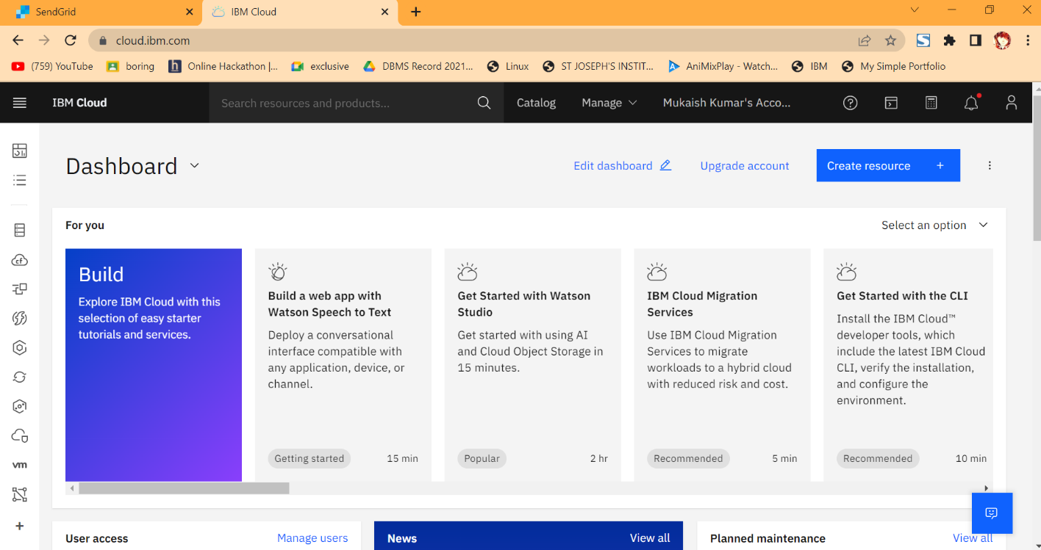**Step 1.** Navigate to cloud.ibm.com

**Step 2**. Search on Container Registry and give get started and follow the steps to install IBM Cloud CLI

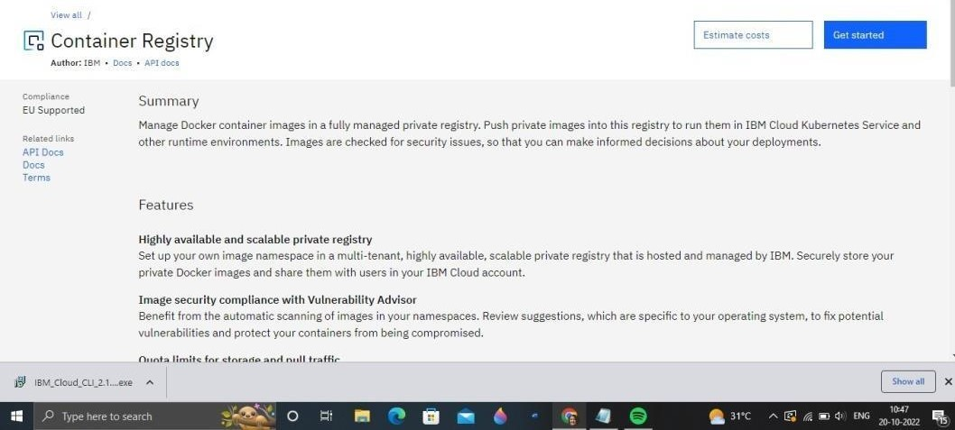

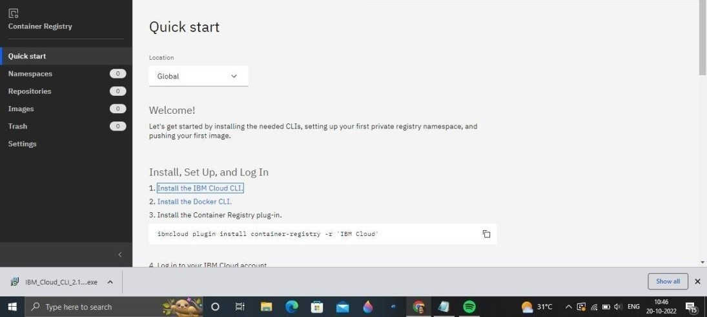

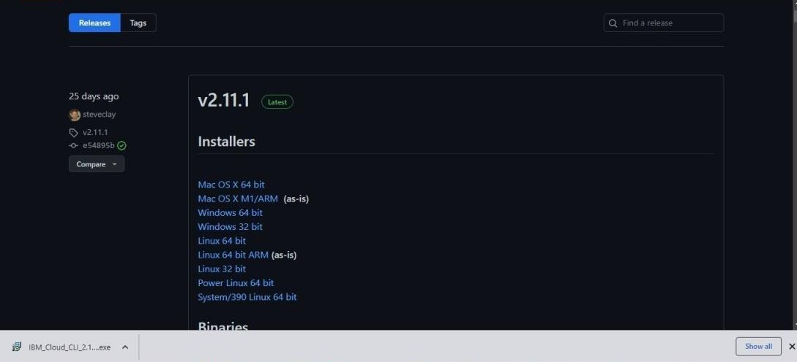**Step 3**.Download windows 64 bit installer

**Step 4.** Open the downloaded .exe file and run it to install IBM Cloud CLI

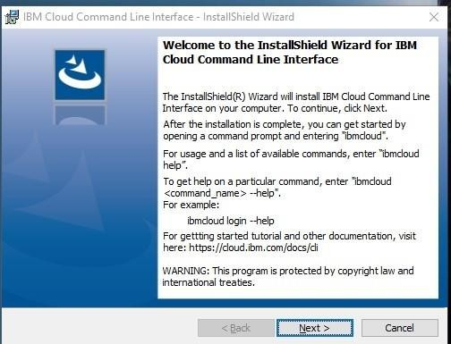

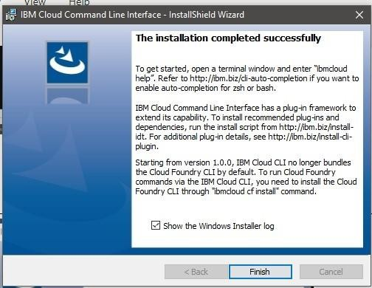

# OUTPUT:

IBM Cloud CLI is installed successfully